100 RÉIS, 1844

Resultado do leilão da venda de uma moeda em maio de 2008

Claudio Schroeder

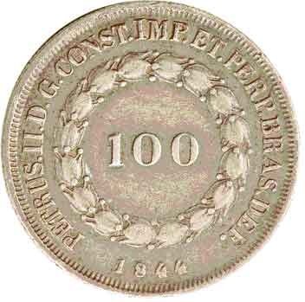

Em tempo. O resultado completo do leilão pode ser verificado no site da Heritage Numismatic Auctions: http://coins.ha.com

Esse exemplar de 100 réis de 1844 foi vendido por US$ 83.375,00.

Raridade clássica da numismática brasileira, será ofertada a venda em leilão publico na América do Norte. O leilão de moedas vai ser realizado pela firma Heritage Numismatic Auctions no final do mês de maio.

Catálogo e demais detalhes na Internet: http://coins.ha.com

Segue descrição do catálogo:

Lot 50642 Pedro II 100 Reis 1844, KM452, toned XF, one of the greatest Brazilian rarities--finest of only three known. From the founding of the first mint in the state of Bahia in 1694, Brazil has had three Monetary Systems. The first, which dates from 1695 to 1834, is the so-called "divisional" system. Each denomination was double in value of the previous denominations so the coins in circulation ranged from 20 to 640 Reis. In 1809, Brazil started striking the 960 Reis on the Hispanic 8 Reales, which had just begun circulating in Brazil when the Portuguese Crown was transferred to the Brazilian colony to escape the Napoleonic invasion. Starting in 1834, Brazil, now an independent empire, attempted a new monetary system nicknamed the Cruzado (mainly due to inflation and the need for coins of higher values). With odd denominations of 100, 200, 400, 800, and 1200 Reis, this Cruzado system was rejected by the Brazilian population as they continued to use the older coins. Consequently, instead of increasing mintages, the Empire created a whole new monetary system that was established in 1849. With more "standard" denominations of 100, 200, 500, 1000, 2000 Reis, the new system was a quick success and remained in place until the Cruzeiro monetary reform in 1942. While "failing" with the Cruzado system, the Brazilian empire created one of the rarest numismatic series in the wide collection of Brazilian coins. With 42 coins in total, most of which are scarce or rare, the jewel of the Cruzado series is without a doubt the 1844 100 Reis (or the Tostao).

Estimate: $40,000 - $55,000.

